Persistent river heatwaves cause concern for local residents

Local fishers and water sports enthusiasts might have issues this year as the East Alabama area deals with rising river water temperatures.

Riverine heat waves, where rivers such as the Chattahoochee and the Tallapoosa are prominent water sources, cause fish populations to dwindle and can increase bacteria in the water.

These heat waves are intensifying nationwide. The first in-depth study revealed that river temperatures are increasing faster and lasting longer than air heat waves.

Researchers at Pennsylvania State University analyzed more than 40 years of daily water temperature data from 1,471 river sites across the country. The authors mention that riverine heatwaves are being overlooked because they do not directly impact humans the same way atmospheric heatwaves do. Results showed that the river heat waves are not as frequent or as intense but last about twice as long and are rising faster than atmospheric heat waves.

The study, led by Kayalvizhi Sadayappan and Li Li of The Pennsylvania State University, was published in the “Proceedings of the National Academy of Sciences”.

While these findings reflect a nationwide trend, scientists have found that the most rapid increases were in the Southern and Appalachian regions. Scientists warn that this warming significantly increases stress for river ecosystems, which in turn will influence the lives of Alabama residents who use these waterways.

The authors argue that human-caused climate change is this primary driver of the trend. Other scientists believe thermal pollution from hot surfaces running off into streams also contributes.

Director of Alabama Cooperative Extension System Eve Brantley said impervious surfaces may also contribute to rising river temperatures.

“Warming river systems or heat pollution is a concern,” Brantley said. “A lot of that comes from when it rains, and rain hits a heated surface like a parking lot or a rooftop and it runs off, then that rainwater gets warmed up and it carries into streams which leads into rivers.”

Scientists expect rising temperatures to affect fish species that rely on colder waters such as salmon and trout in northern regions. Warmer waters hold less dissolved oxygen, making it harder for fish and other organisms to survive.

Alumni Professor in the School of Fisheries, Aquaculture and Aquatic Sciences Dennis Devries and his wife and research technician Tammy Devries believe that the increasing river temperature will possibly lead to more local species dying out or moving elsewhere overall affecting relationships of other species.

“All of these relationships are complicated,” DeVries said. “Mussels produce young that latch on to the gill of a fish. They travel with them and feed off them and eventually drop off, but without the diversity of fish, mussels cannot survive. If the temperature kills the fish the mussels cannot complete their lifecycle.”

East Alabama is known for its recreational activities such as fishing, boating and water tourism. These temperature changes could present future issues because of poor water quality and a lack of aquatic game. Additionally, there’s a higher possibility of harmful algae blooms, which can affect both recreational activities. At catastrophic levels, this could also impact drinking water.

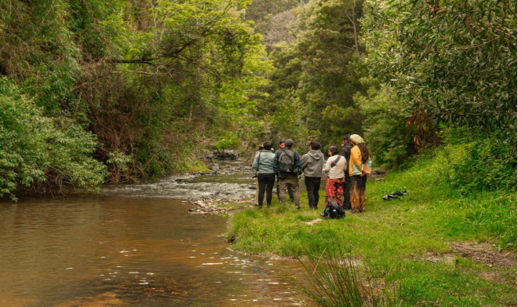
A group from Water Watch gathered by a stream they will sample.
Photo credits: Alabama Water Watch

“Pathogens, like some bacteria, survive longer in warmer waters,” Brantley said. “This could mean a health concern for people who want to get into the water and swim. It may also shift the fishing opportunities for people.”

DeVries said the effects will vary based on the specific temperatures and lifecycle differences of certain aquatic species like mussels or bass.

“This summer we were looking for an invasive species called corbicula. It’s normally in 2 feet of water,” DeVries said. “We couldn’t find them in 8 feet of water because it was so hot. It is changing the way things act. It is a complex system, it is an interplay of everything.”

Efforts to avoid continued river heat waves include planting more native trees, preserving trees in the landscape and adding green infrastructure, such as stormwater bioretention, which slows runoff and allows water to cool before entering streams and rivers.

